Experiential Learning Modules for Students

Instructor Guide

Table of Contents:

- About the modules and guide
- Overview: modules by theme
- How to use these modules in your course or program
- Articulate Storyline module features
- In-depth: module summaries

Appendix

1. About the Experiential Learning Modules

This series of Experiential Learning Modules for students has been created by the Office of the Vice-Provost, Innovations in Undergraduate Education. They were funded in part through the Career-Ready Fund of the Province of Ontario.

The goal of this series of modules is to provide resources to instructors, support staff and students on a range of topics related to experiential learning. These modules can be used in-person (as powerpoint slides, for instance) or online and can be customized to suit your learning objectives. The modules are designed so that instructors or staff can facilitate abbreviated, chunked, or complete versions of each module to students as relevant.

The materials are published as “ready-to-use” modules, as well as editable open educational resources and licensed under a Creative Commons so that they can be adapted and adopted by others.

About this guide

This instructor guide has been prepared for instructors and support staff who are coordinating experiential learning activities. Instructors and support staff who wish to use one or more of the Experiential Learning Modules with their students or program participants.

2. Overview: Modules by Theme

Each of these modules congregate around a particular theme: Preparing for Experiential Learning, Setting Goals and Developing Competencies, and Engaging with the Community. You may want to choose only one module from a specific theme or use all of them depending on your learning objectives. The modules can be used in any combination and order to support your students in their experiential learning activities.
Themes
Preparing for Experiential Learning
Modules in this theme focus on preparing students to engage in experiential learning broadly, including introducing them to new concepts and resources that they may need for a successful experience.

- Roles and responsibilities | - Invites consideration of how their role in experiential learning might differ from the role they traditionally play in their university classes.  - Students introduced to policies and resources to support their learning in this new role.
- Understanding your strengths, values and interests | - Prompts students to consider what strengths, values and interests they have even before beginning their experiential learning opportunity in order to ground their learning and development in their existing understanding of themselves
- Reflection | - Introduces the concept of reflection and to why it is an essential component of experiential learning  - Students practice their reflective skills and learn strategies for developing those skills further
Setting Goals and Developing Competencies
Modules in this theme focus on supporting students to develop their own goals for their experiential learning opportunity.

- Setting goals for experiential learning | - Allows students to think broadly about their goals in a range of areas including disciplinary knowledge, skill and competency development, career development and personal development
- Creating a personal learning plan for competency development | - Used before and after an experience, respectively, to focus on specific competencies students wish to develop  - These types of learning plans for competency development often used in career-oriented experiential learning opportunities
- Reflecting on your competency development
Engaging with the Community
The modules in this theme focus specifically on the form of experiential learning known as community-engaged learning, where students partner with, and learn from, nonprofit or public organizations.
- An introduction to community-engaged learning | - Introduces students to the key features of community-engaged learning and then prompts them to set goals in a range of areas for their community-engaged learning experience.
- Preparing for your community-engaged learning experience | - Module traces how community-engaged learning courses might differ from other kinds of university courses and then offers students some strategies for success in negotiating the expectations of this particular form of experiential learning.

3. How to Use These Modules in Your Course or Program

- Choosing a topic
- Choosing a format
- Choosing how you want to assess student learning

Choosing a topic

These modules are designed to be used or adapted in whatever way best supports your course or program. For instance, you can use abbreviated, chunked, or complete versions of a module and you can combine the parts and wholes of the modules to create a learning opportunity for students that is contextualized to your needs. You may also wish to add content to the modules that provides students with additional activities, material or context.

Consider what kinds of preparation your students might need for their experiential learning opportunity and match those needs with the learning objectives of each module. You can find the learning objectives in this instructor guide (in the “In-depth: Module Summaries Section) as well as near the beginning of each of the modules themselves.

Choosing a format

The modules are available to you in two primary formats: as PowerPoint slides (which are customizable) and as an interactive Articulate Storyline e-learning object (which is not customizable).

Customizable options:
If you wish to customize the modules (that is, make any change to the order or content of any of the modules), you can do so through using the PowerPoint slides. You can adapt and use these slides for your course or program in multiple ways:

- In person:
You can customize the PowerPoint slides and use them in-person in your classroom or program
- In Quercus:
You can customize the PowerPoint slides and then place them in Quercus. With this option you can add in optional interactive pieces through Quercus’s native tool and functions. For more on creating content in Quercus see https://q.utoronto.ca/courses/46670/pages/build-your-course#adding-content
- In Articulate Storyline:
You can customize the PowerPoint slides and use them to create a new Articulate storyline e-learning object. This requires access to, and some expertise in, Articulate Storyline software. You may wish to contact your Dean’s office to inquire about whether your Faculty has this resource available.

Fixed options:
If you wish to use the modules exactly as they appear and want to retain the interactive features of Articulate Storyline, you can use the Articulate Storyline learning objects provided.

- Online link to Module
You can simply provide the link of the module to your students and ask them to complete the online module.

- In Quercus
You can download the .zip file of the module for use in your own Quercus course shell. For full instructions on how to upload the file into Quercus see Appendix A.

Choosing how to assess student learning

You may wish to validate and/or assess your students’ engagement with these experiential learning modules and you can do so in various ways.

In the classroom: Slides
If you use these slides in the classroom, you can invite students to complete the written activities either in or out of class and then submit their responses to you for assessment.

Out of the classroom: Slides
If you use these slides in Quercus, you may create quiz questions to track students’ progress and understanding. Using the assignments feature in Quercus you can ask students to write or submit a document of their responses to the activities in the slides.

Out of the classroom: Articulate Storyline object:
Whether or not you use the Articulate Storyline object version of the modules in Quercus or just as a link, your students can download their responses as a PDF and submit them to you.

If you use the module in Quercus in this way, you can also track which students went through the module as there will be a grade book column generated that will show completion status.

Instructions for students to print their responses in the Articulate Storyline object:

- Students should type their responses when prompted into the text boxes in the module.
- When students arrive at the end of the module, they will encounter a “Print Your Responses” screen.
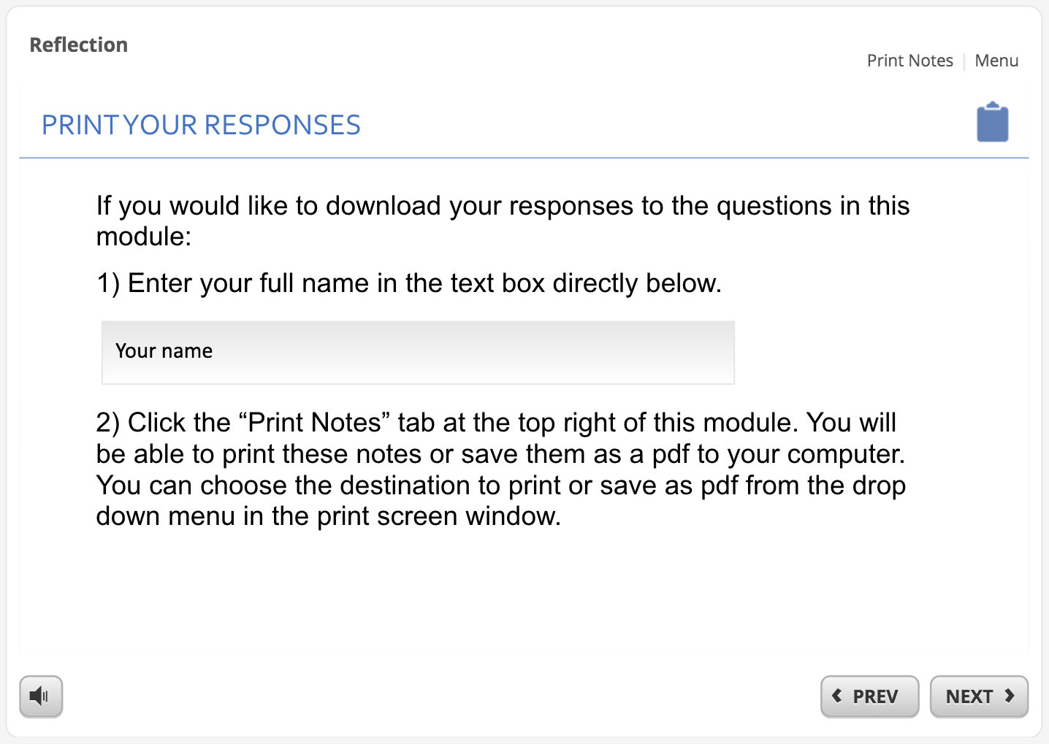

- Students should enter their full name and click the “Print Notes” tab at the top right of the module. A pop-up screen will appear with all of their responses for that module.
- Students can then print their responses or save them as a PDF for submitting to their instructor/program coordinator.

4. Articulate Storyline: Module Features

In the Articulate Storyline learning object format of these modules, multiple interactive features have been built into each module including:

- Links to other resources
- Questions to be answered and other writing prompts (with text boxes)
- Quizzes to check for understanding

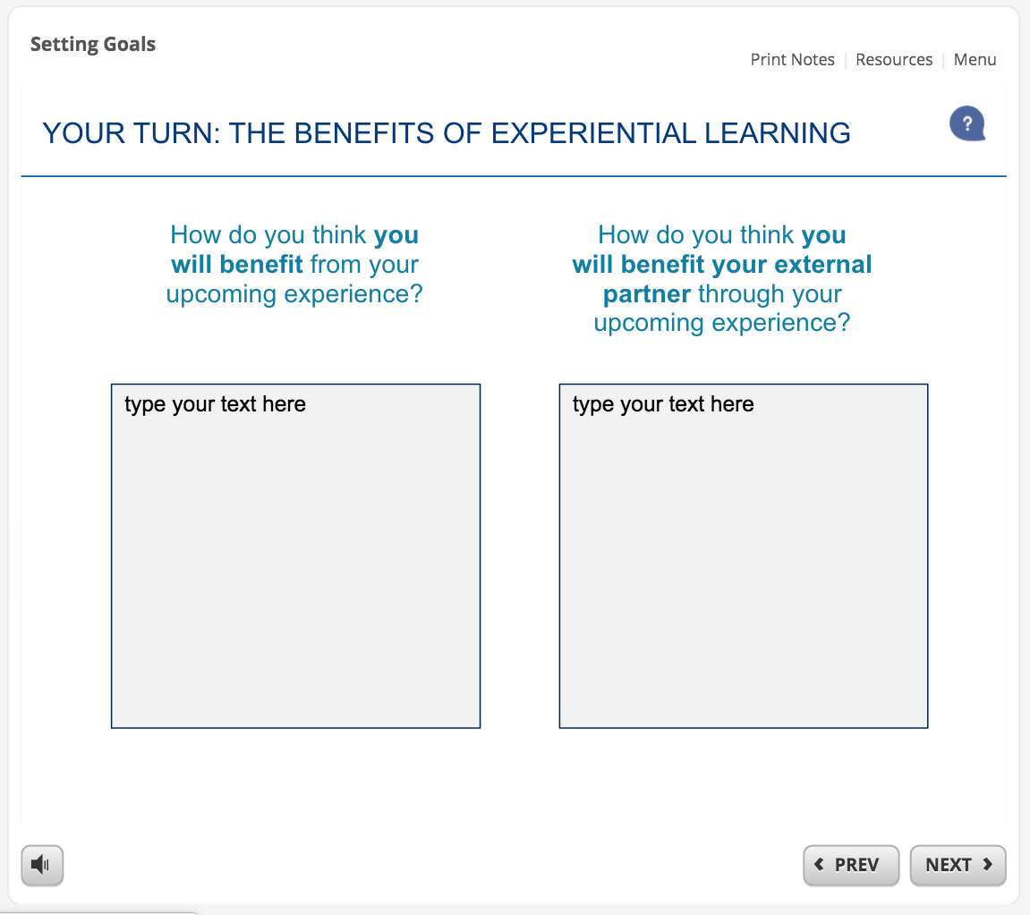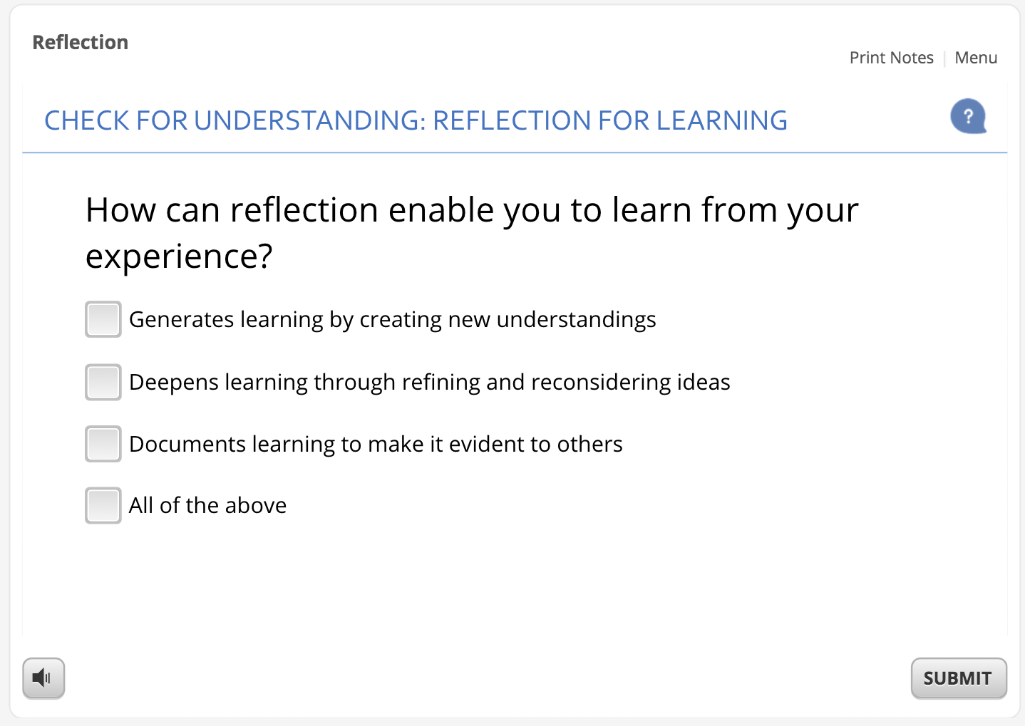

This format also contains “Print Notes,” “Resources” and “Menu” tabs on the top right of the module.

Print notes: Students can see their text box responses collated in this tab. This tab can also be printed or saved to a computer as a pdf document.

Resources: This tab contains any additional resources that are linked to in the module (eg. worksheets for an activity).

Menu: A menu listing the title of each slide is available in this tab.

5. In-depth: Module Summaries

Module 1: Setting Goals
Theme: Preparing for experiential learning
Expected time to completion: 30 mins
Module Learning Objectives | Module Topics and Subtopics
By the end of this module, students will:  - Be more familiar with strategies they can use before and during the experience to ensure success  - ​Be aware of University of Toronto resources and policies that may apply to this experience​ | - The value of goal setting [video]  - What is experiential learning?  - Establishing your goals  - What are the benefits of experiential learning for you? [student activity]  - Approaches to goal setting  - Student example: establishing goals in an EL opportunity  - Your goals for disciplinary knowledge? [student activity]  - Your goals for skill and competency development? [student activity]  - Your goals for career development? [student activity]  - Your goals for personal development? [student activity]  - Aligning your goals with your experiential learning opportunity  - Creating your own learning experience  - Student example: placement at a food bank  - Student example: creating learning opportunities  - Student example: learning through reflection  - Aligning goals: learning about your organization  - Aligning your goals [student activity]  - Aligning goals: some final tips

Module 2: Understanding Your Strengths, Values and Interests
Theme: Preparing for experiential learning
Expected time to completion: 15 mins
Module Learning Objectives | Module Topics and Subtopics
By the end of this module, students will:  - Be able to recognize the benefits of identifying their strengths, values and interests​  - Be able to articulate how their strengths, values and interests relate to an experience | - Why consider your strengths, values and interests?  - What are strengths, values and interests?  - Identifying strengths, values and interests from experience  - The presence of your strengths, values and interests  - Student example: Qin’s story  - Student example: Qin’s strengths, values and interests  - Articulating your Strengths, Values and Interests  - A previous successful experience you’ve had [student activity]  - What strengths are revealed by your story [student activity]  - What values are revealed by your story [student activity]  - What interests are revealed by your story [student activity]  - Your strengths, values and interests in action

Module 3: Reflection
Theme: Preparing for experiential learning
Expected time to completion: 30 mins
Module Learning Objectives | Module Topics and Subtopics
By the end of this module, students will:  - Understand what reflection is and why it is essential to experiential learning​  - Have practiced reflecting on their own experiences ​  - Have learned strategies for improving their reflective skills​ | - The value of reflection [video]  - Reflection in experiential learning  - What is experiential learning?  - What is reflection?  - Learning from experience  - Reflection is integrative  - How we learn through reflection?  - Reflection is both a process and a product  - Practicing reflection  - Reflecting on a recent event [student activity]  - What? So what? Now what?  - Student example: reflection  - Strategies for reflective practice  - Reflection is a skill  - Reflection is an ongoing process  - Continuous practice is important  - Move from description to analysis  - Reflection for learning [quiz]  - Your reflective experience [student activity]  - The challenges of reflection

Module 4: Setting Goals for Experiential Learning
Theme: Setting goals and developing competencies
Expected time to completion: 30 mins
Module Learning Objectives | Module Topics and Subtopics
By the end of this module, students will:  - Be able to Identify the characteristics of experiential learning​  - Have considered a variety of types of goals for experiential learning​  - Have explored their goals as well as how they might align with their external partners’ goals | - The value of goal setting for experiential learning [video]  - What is experiential learning?  - Establishing your goals:  - The benefits of experiential learning [student activity]  - Approaches to goal setting  - Student example: establishing goals  - Your goals for disciplinary knowledge [student activity]  - Your goals for skill and competency development [student activity]  - Your goals for career development [student activity]  - Your goals for personal development [student activity]  - Aligning your goals with your experiential learning opportunity  - Creating your own learning experience  - Student example: placement at a food bank  - Student example: creating learning opportunities  - Student example: learning through reflection  - Aligning goals: learning about your organization  - Aligning your learning goals [student activity]  - Aligning goals: some final tips

Module 5: Creating a Personal Learning Plan for Competency Development
Theme: Setting goals and developing competencies
Expected time to completion: 30 mins
Module Learning Objectives | Module Topics and Subtopics
By the end of this module, students will:  - Understand what a competency is  - Have identified competencies to develop during their experiential learning opportunity  - Have established “SMART” goals to support competency development​ | - The value of goal setting [video]  - What are competencies?  - Competencies definition  - An example of a competency  - Why consider competencies in career development?  - Competencies and your professional development  - What is a personal learning plan?  - Your long-term career goals [student activity]  - Competencies for development [student activity]  - Previous competency experience [student activity]  - Setting goals for competency development  - Establishing SMART goals  - Which of these is a SMART goal? [quiz]  - Your SMART goals [student activity]  - Using your personal learning plan

Module 6: Reflecting on Your Competency Development
Theme: Setting goals and developing competencies
Expected time to completion: 30 mins
Module Learning Objectives | Module Topics and Subtopics
By the end of this module, students will:  - Have identified which competencies they developed during their experiential learning opportunity  - Be able to articulate those competencies effectively in resumes and interviews | - Identifying your competencies for career success  - What is a competency?  - Competencies definition  - An example of a competency  - Student example: the results of competency development  - Identifying the competencies you developed  - Identifying your competencies  - Student example: the results of competency development  - Which competencies did you develop? [student activity]  - Articulating your competencies in resumes and interviews  - Articulating your competencies in resumes  - Accomplishment statements and resumes  - Communicating your accomplishments  - Competencies as accomplishment statements [student activity]  - Articulating your competencies in interviews  - Student example: STAR method interviewing  - The STAR method for interviews [student activity]  - Focusing on competencies and results  - Resume and interview resources

Module 7: An Introduction to Community-Engaged Learning
Theme: Engaging with the community
Expected time to completion: 30 mins
Module Learning Objectives | Module Topics and Subtopics
By the end of this module, students will:  - Be able to describe the key features of community-engaged learning (CEL)​  - Have reflected on their goals for their CEL experience  - Have considered how to align their goals with their community partner’s priorities | - What is community-engaged learning (CEL)?  - CEL definition  - Why CEL? The benefits for students and communities [video]  - Key features of CEL  - Key feature: experiential  - Key feature: addresses community needs  - What is “reciprocity” in CEL? [video]  - The value of reciprocity [student activity]  - Key feature: incorporates reflection  - How we learn through reflection  - Reflection is both a process and a product  - The value of reflection [video]  - Key feature of CEL: tied to learning outcomes  - Reflecting on your learning goals  - Student example: establishing goals  - Your goals for disciplinary knowledge [student activity]  - Your goals for skill and competency development [student activity]  - Your goals for career development [student activity]  - Your goals for personal and civic development [student activity]  - Aligning your goals with your community partner’s priorities  - Creating your own learning experience  - Student example: placement at food bank  - Student example: creating learning opportunities  - Student example: learning through reflection  - Aligning goals: learning about your organization  - Aligning your learning goals [student activity]  - Aligning goals: some final tips  - Summary: An Introduction to CEL

Module 7: An Introduction to Community-Engaged Learning
Theme: Engaging with the community
Expected time to completion: 30 mins
Module Learning Objectives | Module Topics and Subtopics
By the end of this module, students will:  - Recognize how a community-engaged learning (CEL) course might differ from other courses  - Have developed strategies to maximize their learning in a CEL course | - What is community-engaged learning (CEL)?  - CEL definition  - Key features of CEL  - What to expect in a CEL course  - Your expectations for your CEL course [student activity]  - How a CEL course may differ from other courses [video]  - Unique characteristics of CEL  - CEL as “counternormative”  - Learning from the challenges of CEL  - Ensuring a successful CEL experience  - Preparing for a successful CEL experience  - Pillars of a successful CEL experience  - Pillar: Independent learning  - Independent learning in a previous experience [student activity]  - Features of independent learning in CEL  - Pillar: the application of knowledge  - Applying knowledge in a previous experience [student activity]  - Features of the application of knowledge  - Pillar: an emphasis on reflection  - Previous experience with reflection [student activity]  - Features of successful reflection in CEL  - Pillar: community partnership  - Previous experience with community engagement [student activity]  - Features of respectful community engagement  - Considering your approach to community engagement  - What should students know before their CEL experience? [video]

Appendix A

Uploading Module to Quercus

The experiential learning modules have been created and published in Articulate Storyline 360. A .zip file of each module is available to be used in a learning management system (LMS) as a SCORM object and will play and display as seen on the website. Follow these instructions for uploading a module into Quercus. We use the “Reflection” module as an example:

1) Navigate to the relevant module. Select the ZIP FILE (SCORM) object. This will automatically download a .zip file of the published module to your computer.

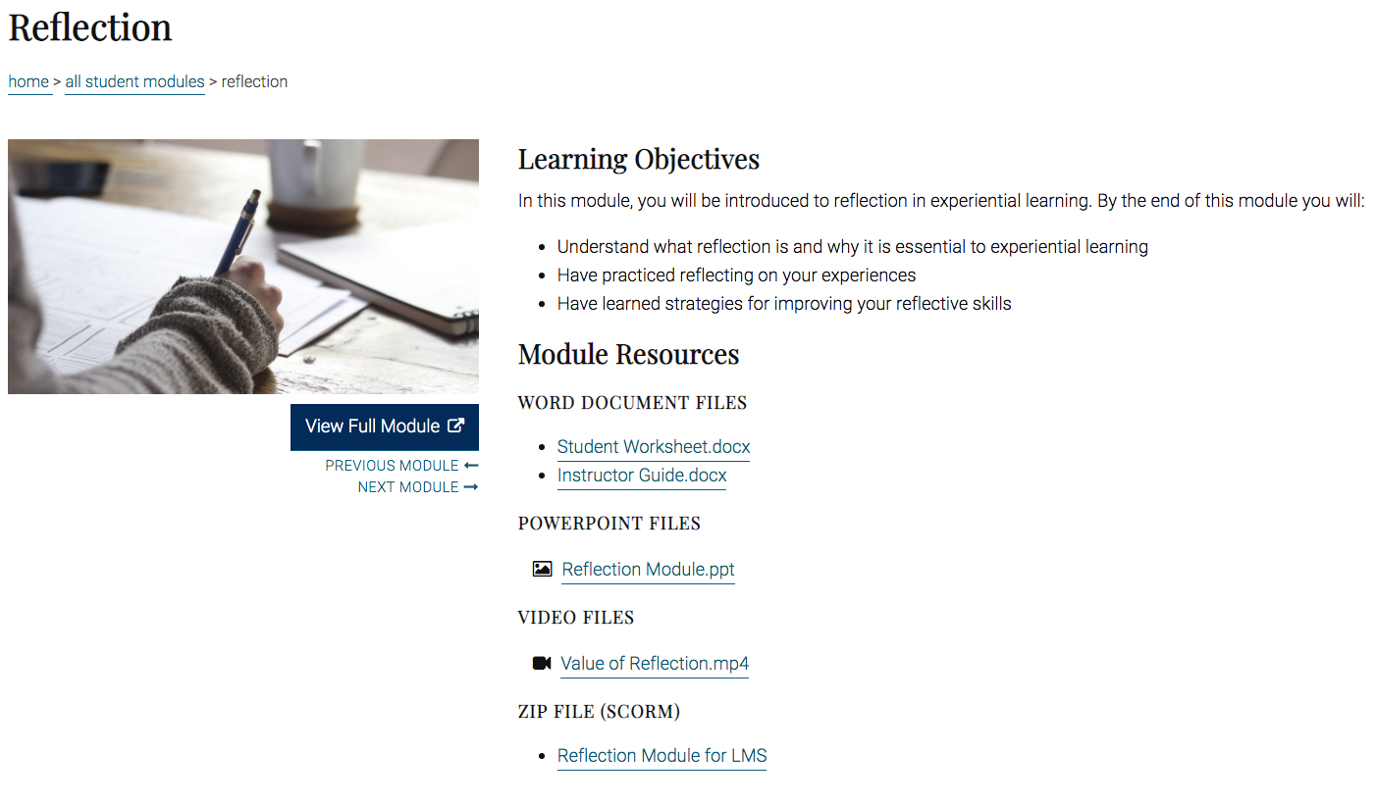

2) If you have NOT enabled SCORM in Quercus begin by selecting the “Settings” tab in the main navigation menu.

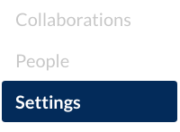

3) Once in Settings, select the “Navigation” tab.

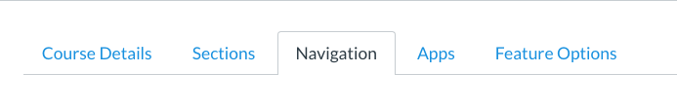

4) Scroll down the page until you see the SCORM navigation item (by default hidden from your menu).

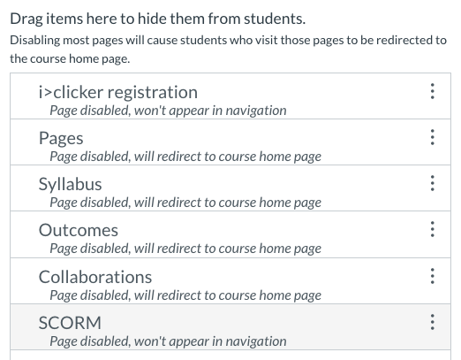

5) Drag the SCORM item up into the visible menu items list and SAVE. It will now be visible in the menu and you can add SCORM objects.

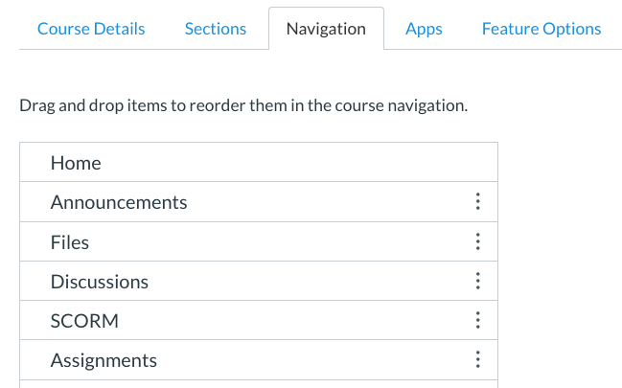

6) With SCORM now available in the course menu, select the “SCORM” tab.

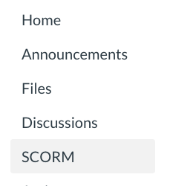

7) Choose the “Upload” button found on the top, right of the screen to access a .zip file.

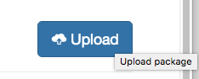

8) Search for and select the module .zip file you downloaded from the experiential modules website.

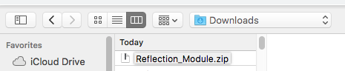

9) Once it is uploaded you can scroll to find the module and you may import is as a graded or ungraded assignment. We will select ungraded.

10) Be sure to publish the item. It can now be used as an assignment in any module in Quercus.

11) By default, when a SCORM object is added as an assignment it will open in the same window when a user selects that item in Quercus. This can be changed to open in a new window if preferred. Begin by navigating to the assignment and select the option to edit the assignment. Select the “More Options” button.

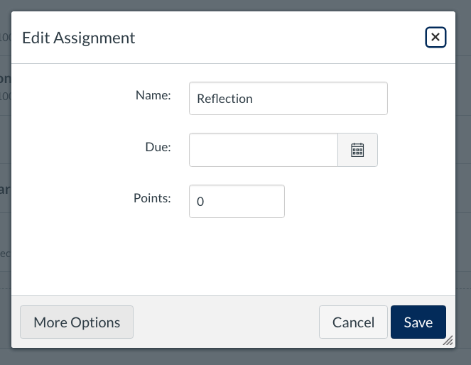

12) You may edit different defaults, and under “Submission Type” select the “Load This Tool In A New Tab” option. A user will now be able to launch the module in a new window.

